**Task 1: Nested Loop**

; You may customize this and other start-up templates;

; The location of this template is c:\emu8086\inc\0_com_template.txt

; write a code in assembly language to perform the following operations

;1. read a character in upper case and display the same character in lower case

;2 read a small letter and display in upper case

.model small

.stack 100h

.data

str1 db "0$"

str2 db "University$"

.code

main proc

;

mov ax,@data

mov ds,ax

sub cx,cx

mov cx,6

label1:

mov bx,cx

mov cx,10

label2:

mov ah,09

lea dx,str1

int 21h

inc str1

loop label2

mov cx,bx

mov ah,02

mov dl,0dh

int 21h

mov dl,0ah

int 21h

mov bl,'0'

mov str1,bl

loop label1

main endp

end main

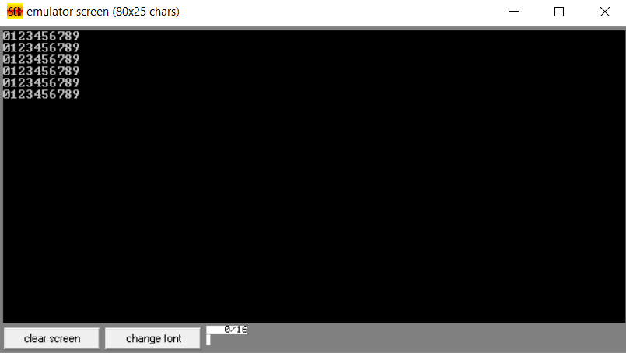

**Task 2: Pattern**

; You may customize this and other start-up templates;

; The location of this template is c:\emu8086\inc\0_com_template.txt

; write a code in assembly language to perform the following operations

;1. read a character in upper case and display the same character in lower case

;2 read a small letter and display in upper case

.model small

.stack 100h

.data

str1 db "1$"

str2 db "1$"

.code

main proc

;

mov ax,@data

mov ds,ax

;sub cx,cx

mov cx,5

label1:

mov bx,cx

mov cx,bx

label2:

mov ah,09

lea dx,str1

int 21h

inc str1

loop label2

mov cx,bx

mov ah,02

mov dl,0dh

int 21h

mov dl,0ah

int 21h

mov str1,'1'

loop label1

main endp

end main

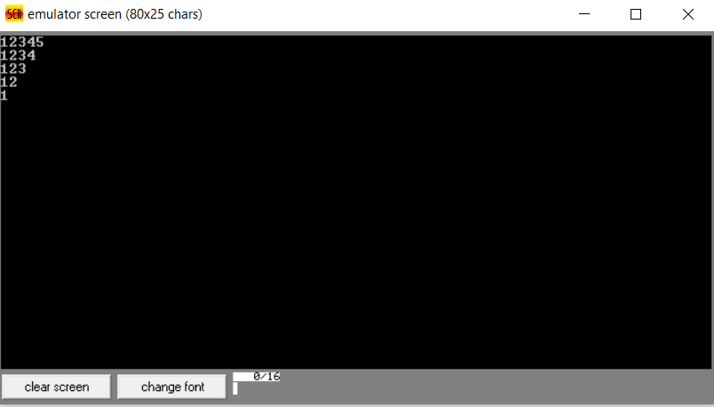

**Task 3: Pattern 2**

; You may customize this and other start-up templates;

; The location of this template is c:\emu8086\inc\0_com_template.txt

; write a code in assembly language to perform the following operations

;1. read a character in upper case and display the same character in lower case

;2 read a small letter and display in upper case

.model small

.stack 100h

.data

str1 db "1$"

str2 db 1

.code

main proc

;

mov ax,@data

mov ds,ax

;sub cx,cx

mov cx,5

label1:

mov bx,cx

mov cx,str2

label2:

mov ah,09

lea dx,str1

int 21h

inc str1

loop label2

inc str2

mov cx,bx

mov ah,02

mov dl,0dh

int 21h

mov dl,0ah

int 21h

mov str1,'1'

loop label1

main endp

end main

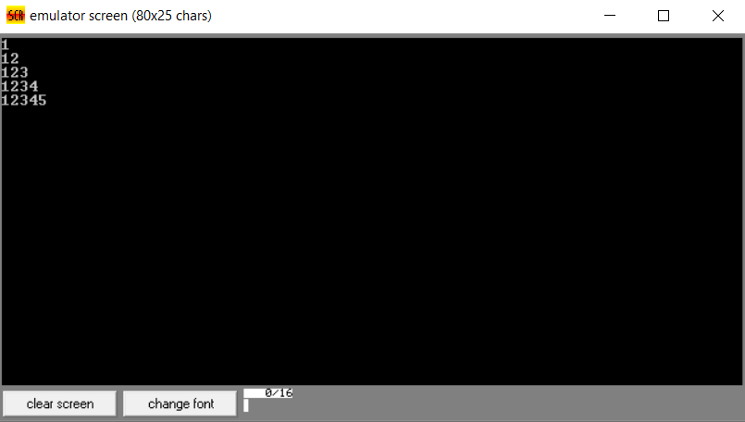

**Task4: pattern 4 (asterisk)**

; You may customize this and other start-up templates;

; The location of this template is c:\emu8086\inc\0_com_template.txt

; write a code in assembly language to perform the following operations

;1. read a character in upper case and display the same character in lower case

;2 read a small letter and display in upper case

.model small

.stack 100h

.data

str1 db "*$"

str2 db 1

.code

main proc

;

mov ax,@data

mov ds,ax

;sub cx,cx

mov cx,5

label1:

mov bx,cx

mov cx,str2

label2:

mov ah,09

lea dx,str1

int 21h

;inc str1

loop label2

inc str2

mov cx,bx

mov ah,02

mov dl,0dh

int 21h

mov dl,0ah

int 21h

mov str1,'*'

loop label1

main endp

end main

